|  |  |  |
| --- | --- | --- |
| Product Catalogue | IDC connector (horn/mini-horn) |  |
| Connector Type | Mini-horn seat |  |
| Spacing | 2mm |  |
| Row Number | 2 |  |
| Line Spacing | 2mm |  |
| Package Form | Straight-in insertion |  |
| Contact Material | Brass |  |
| Contact Plating Layer | Gold |  |

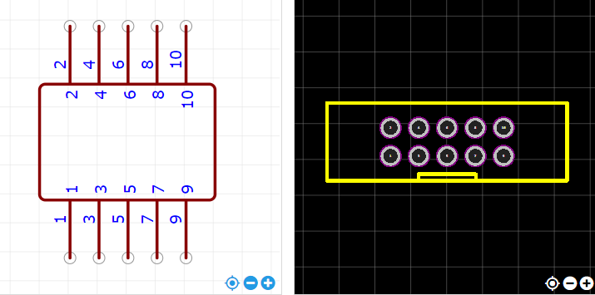

<https://item.szlcsc.com/221677.html>